Latissimus dorsi

Origin:
- Spines of lower six thoracic vertebrae
- Posterior lamina of thoraco-lumbar fascia
- Outer lip of posterior part of iliac crest
- Lower three ribs
- Inferior angle of scapula
Course:
Muscle forms a sheet at its superior aspect – this sheet curves around the inferolateral border of teres major. With teres major, latissimus dorsi forms posterior fold of axilla
Insertion:
- Floor of intertubercular sulcus

[TIP]With thoraco-dorsal artery, this muscle and covering skin can be flap can be used as musculocutaneous flap for reconstruction of breast post mastectomy
[WARNING]Latissimus dorsi – can be used to reconstruct left ventricle in cases of dilated cardiomyopathy
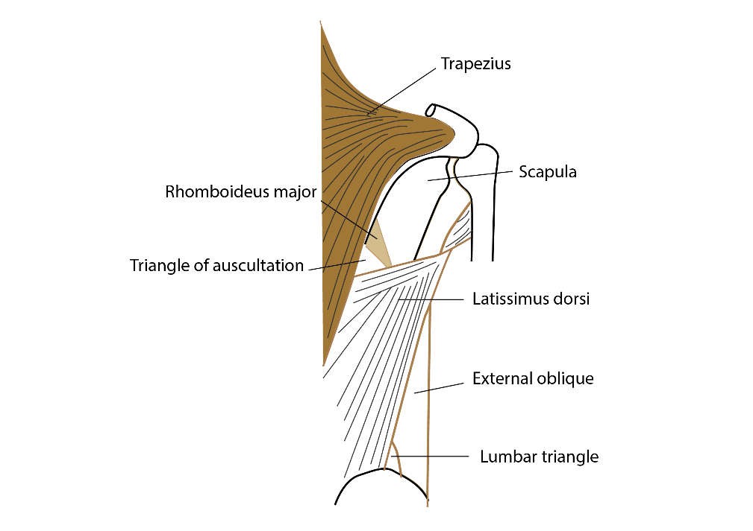

Nerve supply:
thoraco-dorsal nerve
Arterial supply: by a single dominant thoraco-dorsal artery

Action:
- Pulls the lower trunk up as in climbing
- Assist in backward swinging of arm in walking
- Adduction, extension and rotation of shoulder
- Accessory respiratory muscle

Triangle of auscultation
Intermuscular gap in posterior thoracic wall
Boundaries:
- Medially – Latissimus dorsi
- Inferolaterally – trapezius
- Laterally – Scapula medial border

[CLINICAL]Breath sounds are better heard over this area

